Network Cables and connector

Q1. Draw a labelled diagram of a Cat6 Ethernet cable, showing the colour order of wires in the T568B standard and labelling the RJ-45 connector pins.
Ans. 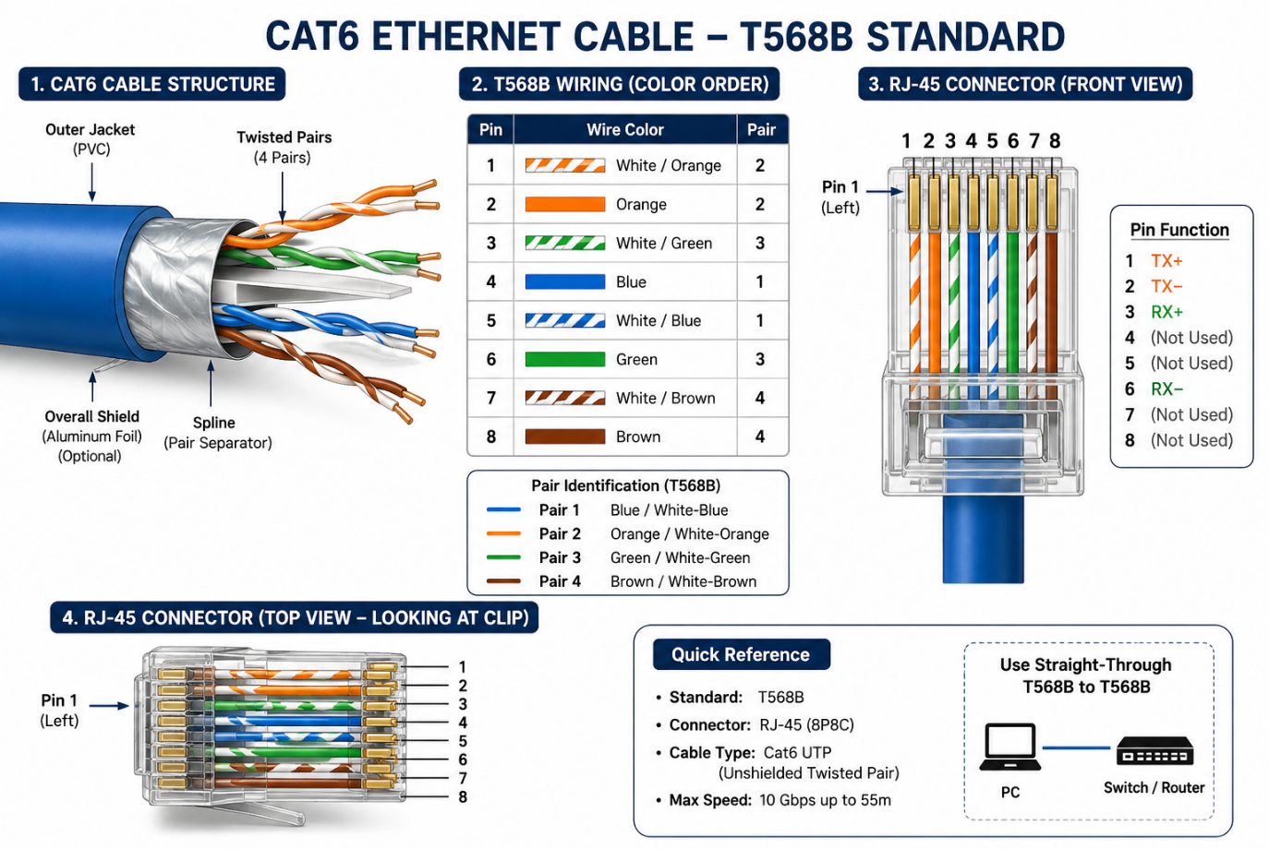
Q2. List three types of network cables (such as Cat5e, Cat6, and fibre optic) and for each, mention one real-world app or device (like a Wi-Fi router, Zomato POS terminal, or IPL streaming server) where it would be used, explaining why.
Ans.
Network Cable | Real-world App / Device | Why it is used
Cat5e | Zomato POS terminal | It is affordable and supports speeds up to 1 Gbps, which is enough for billing, orders, and payments.
Cat6 | Wi-Fi Router | It supports higher speeds and has less interference, making it good for fast home or office internet connections.
Fiber Optic | IPL Streaming Sever / Data Center | It can carry huge amounts of data at very high speeds over long distances, making it suitable for live video streaming to many users.

Q3. Watch a YouTube video showing how to crimp an RJ-45 connector onto a network cable, then write down the step-by-step process in your own words and mention two common mistakes to avoid.
Ans. Step-by-step process
- Cut the Ethernet cable to the required length.
- Strip about 2 cm of the outer jacket carefully without damaging the small wires inside.
- Untwist and straighten the eight wires.
- Arrange them according to the T568B colour order:
White-Orange → Orange → White-Green → Blue → White-Blue → Green → White-Brown → Brown.
- Trim all eight wires evenly so they are the same length.
- Hold the RJ-45 connector correctly and push all eight wires fully inside, making sure each wire reaches the end of the plug.
- Make sure part of the outer cable jacket is also inside the connector so the connector can grip it securely.
- Put the RJ-45 connector into the crimping tool and squeeze firmly to lock the pins onto the wires.
- Repeat the process on the other end of the cable using the required wiring standard.
- Finally, test the cable with a network cable tester to make sure all eight connections work correctly.

Q4. Given the following scenario: You are setting up a gaming zone for an IPL screening event and need to connect multiple screens and consoles. Choose the appropriate cable and connector types for high-speed, reliable connections, and explain your choices.

Ans. For an IPL gaming and screening zone, I would use:
- Cat6 Ethernet cable with RJ-45 connectors to connect gaming consoles, PCs, routers, and switches. Cat6 provides fast, stable network speeds with low interference, which is important for online gaming and streaming.
- HDMI cables with HDMI connectors to connect consoles or media players to TVs and large screens. HDMI carries high-quality video and audio through one cable.
This setup gives a fast and reliable internet connection for gaming while providing clear, high-quality video and sound for the IPL screening.

Q5. Find and share a photo (from your home, college, or online) of any network cable or connector in use (such as behind a Wi-Fi router or at a cafe's POS counter), and describe what type it is and what devices it connects. Hint: Look for blue or yellow cables with clear plastic ends (RJ-45) or thin round cables for fibre optics.

Ans.
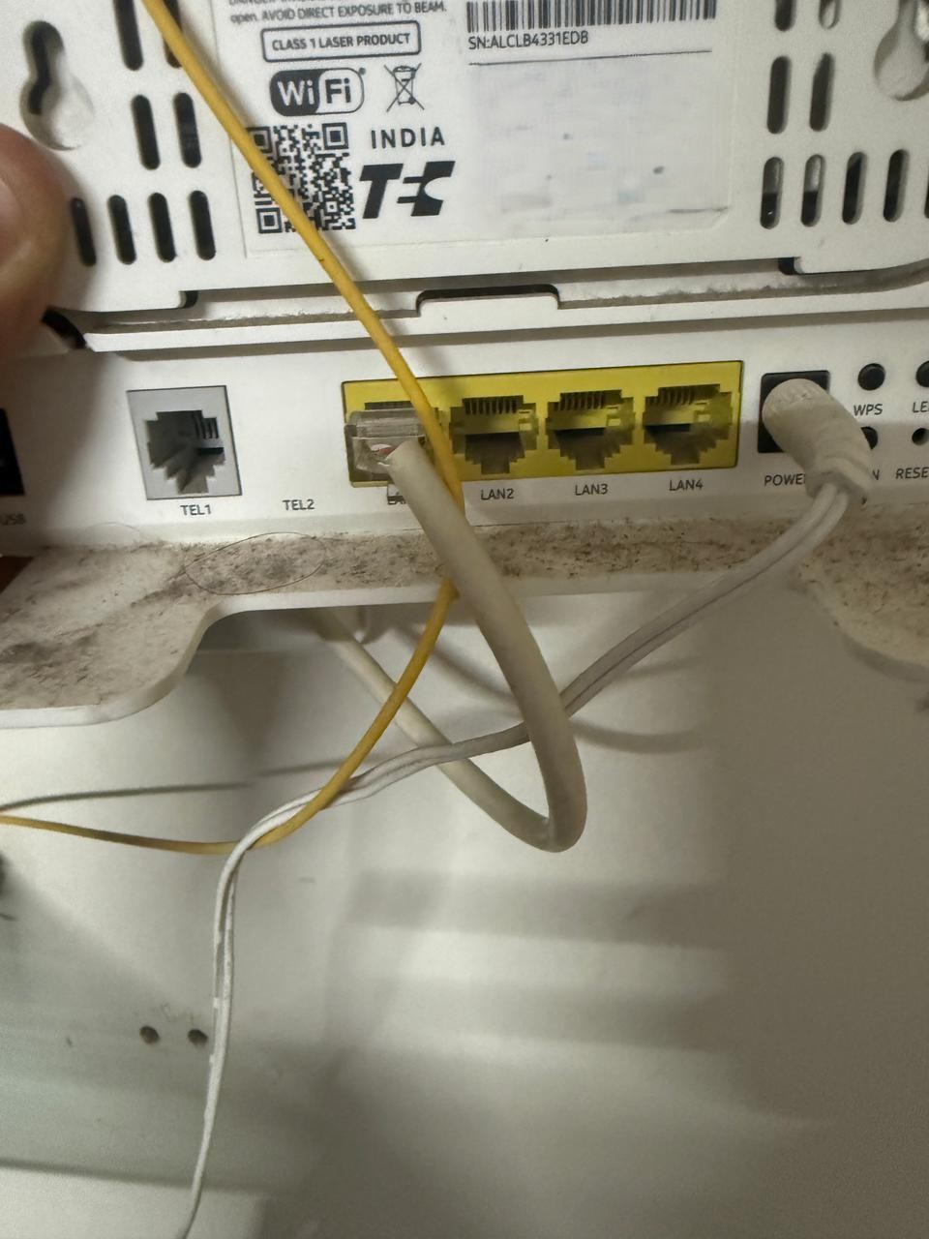

Description:
- The photo shows an Ethernet network cable with an RJ-45 connector being used with a Wi-Fi router. The clear plastic RJ-45 plug fits into one of the router’s Ethernet ports.
- This Ethernet cable is Cat5e Type, and it is connected to my pc to My Wi-Fi router. A wired Ethernet connection is useful because it provides a stable and fast network connection compared with relying only on Wi-Fi.

